**Task 8**

These are the Screenshots for the given task; 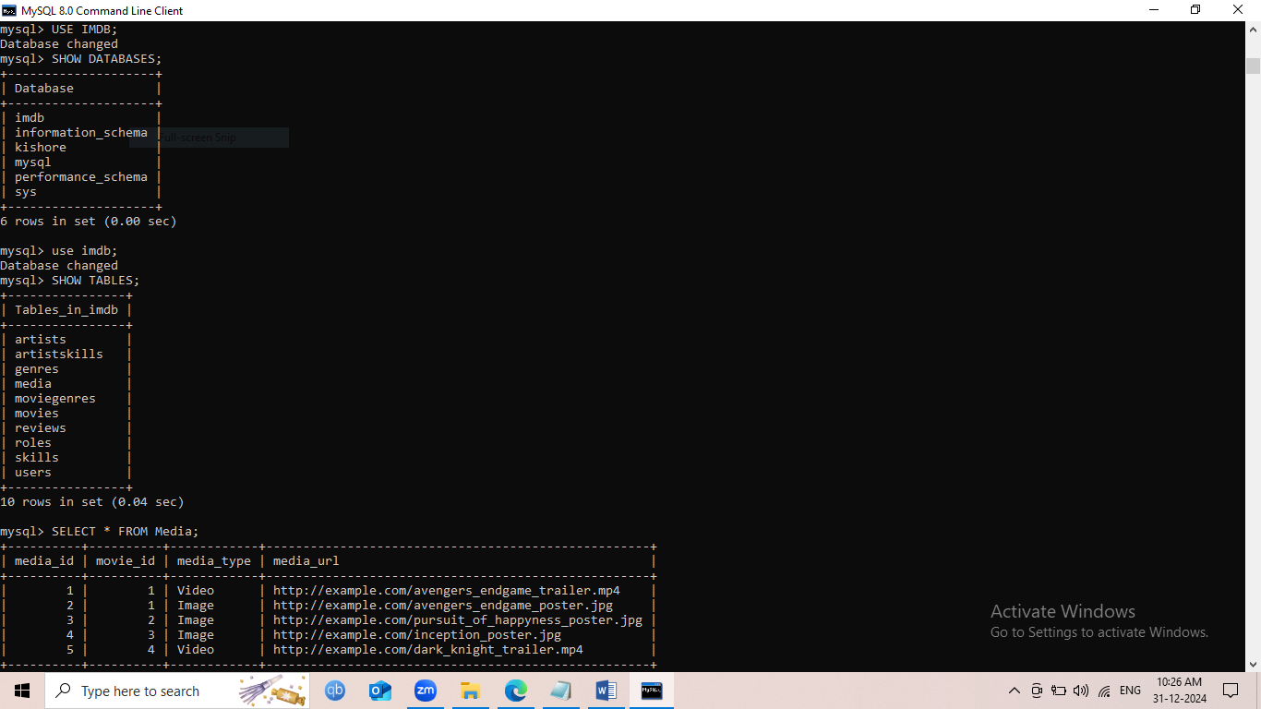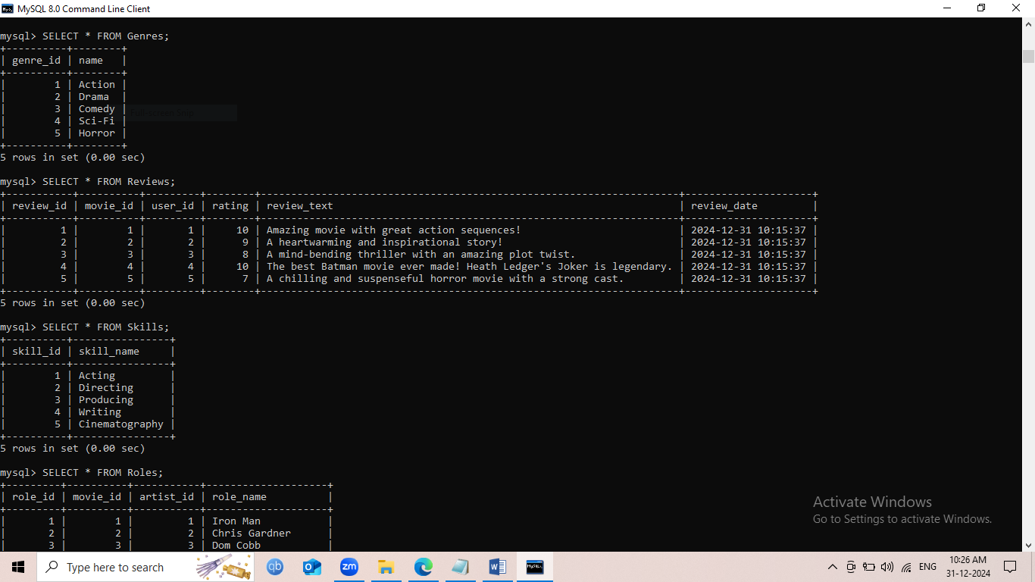 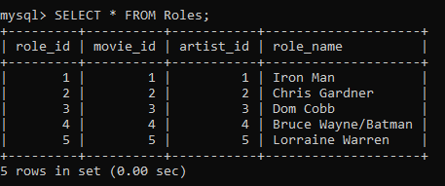

These are the Codes for the Task 8;

USE imdb;

-- 1. Movies Table

CREATE TABLE Movies (

movie_id INT AUTO_INCREMENT PRIMARY KEY,

title VARCHAR(255) NOT NULL,

release_date DATE,

director VARCHAR(255),

duration INT, -- Duration in minutes

description TEXT

);

-- 2. Media Table (for storing videos or images related to movies)

CREATE TABLE Media (

media_id INT AUTO_INCREMENT PRIMARY KEY,

movie_id INT,

media_type ENUM('Video', 'Image') NOT NULL, -- Media type: Video or Image

media_url VARCHAR(255) NOT NULL,

FOREIGN KEY (movie_id) REFERENCES Movies(movie_id) ON DELETE CASCADE

);

-- 3. Genres Table

CREATE TABLE Genres (

genre_id INT AUTO_INCREMENT PRIMARY KEY,

name VARCHAR(100) NOT NULL

);

-- 4. MovieGenres Table (junction table for many-to-many relationship between movies and genres)

CREATE TABLE MovieGenres (

movie_id INT,

genre_id INT,

PRIMARY KEY (movie_id, genre_id),

FOREIGN KEY (movie_id) REFERENCES Movies(movie_id) ON DELETE CASCADE,

FOREIGN KEY (genre_id) REFERENCES Genres(genre_id) ON DELETE CASCADE

);

-- 5. Users Table (stores user information)

CREATE TABLE Users (

user_id INT AUTO_INCREMENT PRIMARY KEY,

username VARCHAR(255) NOT NULL UNIQUE,

email VARCHAR(255) NOT NULL,

password VARCHAR(255) NOT NULL

);

-- 6. Reviews Table (stores reviews written by users for movies)

CREATE TABLE Reviews (

review_id INT AUTO_INCREMENT PRIMARY KEY,

movie_id INT,

user_id INT,

rating INT NOT NULL, -- Rating scale, e.g., 1 to 10

review_text TEXT,

review_date TIMESTAMP DEFAULT CURRENT_TIMESTAMP,

FOREIGN KEY (movie_id) REFERENCES Movies(movie_id) ON DELETE CASCADE,

FOREIGN KEY (user_id) REFERENCES Users(user_id) ON DELETE CASCADE

);

-- 7. Artists Table (stores information about the artists like actors and directors)

CREATE TABLE Artists (

artist_id INT AUTO_INCREMENT PRIMARY KEY,

name VARCHAR(255) NOT NULL,

birthdate DATE,

bio TEXT

);

-- 8. Skills Table (stores skills that artists can have)

CREATE TABLE Skills (

skill_id INT AUTO_INCREMENT PRIMARY KEY,

skill_name VARCHAR(100) NOT NULL

);

-- 9. ArtistSkills Table (junction table for many-to-many relationship between artists and skills)

CREATE TABLE ArtistSkills (

artist_id INT,

skill_id INT,

PRIMARY KEY (artist_id, skill_id),

FOREIGN KEY (artist_id) REFERENCES Artists(artist_id) ON DELETE CASCADE,

FOREIGN KEY (skill_id) REFERENCES Skills(skill_id) ON DELETE CASCADE

);

-- 10. Roles Table (stores roles played by artists in movies)

CREATE TABLE Roles (

role_id INT AUTO_INCREMENT PRIMARY KEY,

movie_id INT,

artist_id INT,

role_name VARCHAR(255) NOT NULL, -- Name of the role in the movie

FOREIGN KEY (movie_id) REFERENCES Movies(movie_id) ON DELETE CASCADE,

FOREIGN KEY (artist_id) REFERENCES Artists(artist_id) ON DELETE CASCADE

);

INSERT INTO Genres (name) VALUES

('Action'),

('Drama'),

('Comedy'),

('Sci-Fi'),

('Horror');

INSERT INTO Movies (title, release_date, director, duration, description)

VALUES

('Avengers: Endgame', '2019-04-26', 'Anthony Russo', 181, 'The Avengers assemble once again to fight Thanos.'),

('The Pursuit of Happyness', '2006-12-15', 'Gabriele Muccino', 117, 'A struggling salesman takes custody of his son.'),

('Inception', '2010-07-16', 'Christopher Nolan', 148, 'A thief who enters the minds of others through dream manipulation is given a chance to have his criminal history erased.'),

('The Dark Knight', '2008-07-18', 'Christopher Nolan', 152, 'Batman faces the Joker, a criminal mastermind who wants to create chaos in Gotham City.'),

('The Conjuring', '2013-07-19', 'James Wan', 112, 'Paranormal investigators work to help a family terrorized by a dark presence in their farmhouse.');

INSERT INTO Media (movie_id, media_type, media_url)

VALUES

(1, 'Video', 'http://example.com/avengers_endgame_trailer.mp4'),

(1, 'Image', 'http://example.com/avengers_endgame_poster.jpg'),

(2, 'Image', 'http://example.com/pursuit_of_happyness_poster.jpg'),

(3, 'Image', 'http://example.com/inception_poster.jpg'),

(4, 'Video', 'http://example.com/dark_knight_trailer.mp4');

INSERT INTO Skills (skill_name) VALUES

('Acting'),

('Directing'),

('Producing'),

('Writing'),

('Cinematography');

INSERT INTO ArtistSkills (artist_id, skill_id) VALUES

(1, 1), -- Robert Downey Jr. has Acting skill

(1, 2); -- Robert Downey Jr. has Directing skill

-- Will Smith

INSERT INTO ArtistSkills (artist_id, skill_id) VALUES

(2, 1), -- Will Smith has Acting skill

(2, 2); -- Will Smith has Directing skill

-- Leonardo DiCaprio

INSERT INTO ArtistSkills (artist_id, skill_id) VALUES

(3, 1), -- Leonardo DiCaprio has Acting skill

(3, 2); -- Leonardo DiCaprio has Directing skill

-- Christian Bale

INSERT INTO ArtistSkills (artist_id, skill_id) VALUES

(4, 1), -- Christian Bale has Acting skill

(4, 2); -- Christian Bale has Directing skill

-- Vera Farmiga

INSERT INTO ArtistSkills (artist_id, skill_id) VALUES

(5, 1), -- Vera Farmiga has Acting skill

(5, 2); -- Vera Farmiga has Directing skill

INSERT INTO MovieGenres (movie_id, genre_id) VALUES

(1, 1), -- Avengers: Endgame is of Action genre

(1, 2), -- Avengers: Endgame is also of Drama genre

(2, 2), -- The Pursuit of Happyness is of Drama genre

(3, 1), -- Inception is of Action genre

(3, 4); -- Inception is also of Sci-Fi genre

INSERT INTO Users (username, email, password)

VALUES

('johndoe', 'johndoe@example.com', 'password123'),

('janedoe', 'janedoe@example.com', 'password456'),

('bobsmith', 'bobsmith@example.com', 'password789'),

('alicejohnson', 'alicejohnson@example.com', 'passwordabc'),

('charlesbrown', 'charlesbrown@example.com', 'passwordxyz');

INSERT INTO Reviews (movie_id, user_id, rating, review_text)

VALUES

(1, 1, 10, 'Amazing movie with great action sequences!'),

(2, 2, 9, 'A heartwarming and inspirational story!'),

(3, 3, 8, 'A mind-bending thriller with an amazing plot twist.'),

(4, 4, 10, 'The best Batman movie ever made! Heath Ledger\'s Joker is legendary.'),

(5, 5, 7, 'A chilling and suspenseful horror movie with a strong cast.');

INSERT INTO Roles (movie_id, artist_id, role_name)

VALUES

(1, 1, 'Iron Man'),

(2, 2, 'Chris Gardner'),

(3, 3, 'Dom Cobb'),

(4, 4, 'Bruce Wayne/Batman'),

(5, 5, 'Lorraine Warren');